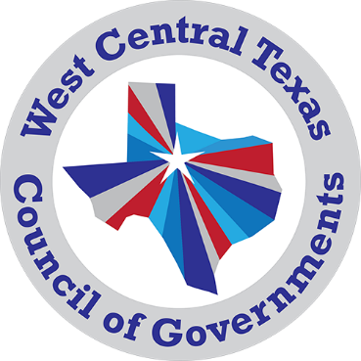
Community and Economic Development Department
3702 Loop 322
Abilene, TX 79602
(325) 672-0495
tnew@westcentraltexas.org

Community & Economic Grant Specialist I
Grant Specialist I Class Code 1919, Salary Group B17, with pay starting at $36,976 depending on qualifications.
Job Description
The WCTCOG manages the economic development district for the Big Country region. The Community & Economic Development department provides our 18 rural counties with the necessary tools and mechanisms to develop and execute local economic development strategies. The grant specialist will perform work directly related to the development and administration of grants that support the goals of the Community & Economic Development programs. Work will involve planning, researching, developing, and implementing department related grant projects. The grant specialist will provide technical assistance to the region for local governments, community organizations, and the public.
Primary Duties and Responsibilities:
- Researches and identifies sources of external funds and assists in the development of proposals to secure funds for new grant opportunities and grant renewal opportunities.
- Performs an array of technical, research, planning, program assessment, and administrative activities related to project assignment.
- Serves as a liaison to staff, government agencies, community organizations, or the public to explain and provide technical assistance on program specifics and requirements.
- Assists with the collection, organization, analysis, and/or preparation of materials in response to requests for project deliverables, information, and reports.
- Assist in the development of requirements for grant programs and in the creation of grant applications that may be awarded by the grantor agency.
- Maintains files and records and prepares reports related to grants issued and/or received.
- Assist in the development of requirements for grant programs and in the creation of grant applications that may be awarded by the grantor agency.
- Provides support and collaborates in the planning, development, implementation, analysis, and documentation of an agency program.
- Performs related work as assigned.
Experience and Education
Experience in the administration, development, coordination, and monitoring of grants. Working knowledge of state and federal funding. Graduation from an accredited four-year college or university with major coursework in public administration, business administration, or a related field is generally preferred. Experience and education may be substituted for one another.
KNOWLEDGE, SKILLS, AND ABILITIES
Skill in grant preparation, development, evaluation, and monitoring; report writing, and the use of a computer and applicable software.
Ability to thoroughly research, collect, and analyze data for grant preparation.
Ability to interpret guidelines, policies, procedures, and regulations; to evaluate fiscal data for reasonableness, necessity, and conformity with grant requirements; and to communicate effectively.
Ability to work effectively and efficiently as a team member within the department to meet all project deliverables.
Organization and time management skills.
Ability to write and speak effectively.
Working Conditions
The Community & Economic Grant Specialist works in the office with occasional work and travel throughout the WCTCOG region.
Monday – Friday 8:30am – 5pm
This is a full-time COG position and is subject to renewal based on program funding.

